Continuing Services Contract for Modeling Support and Limited Access Analysis, Contract No. C9-A66

TECHNICAL MEMORANDUM - DRAFT

**Interstate Access Plan: Phase II Improvement Plan**

**Task 2: Process and Analyze HERE Data**

Prepared for:



Florida Department of Transportation – District 5

719 S. Woodland Boulevard

DeLand, Florida 32129

Prepared by:

Kittelson & Associates

225 East Robinson Street, Suite 450

Orlando, Florida 32801

May 2016

Table of Contents

Background and Summary 1

HERE Data Collection 5

Process and Analyze HERE Data 6

List of Figures

Figure 1: Coverage of HERE Data 5

Figure 2: HERE TMC Locations 8

List of Tables

Table 1: Here Speed Data Time Period 6

Table 2: Peak and Off-peak Months Using Average Speeds 9

Table 3: Peak and Off-peak Months Using Median Speeds 10

Table 4: Average and Median Speeds Difference in May and July 11

Table 5: Highest and Lowest Hourly Speed in Pk Month Weekday and Off-Pk Month Weekday 13

Table 6: Highest and Lowest Hourly Speed in Pk Month Weekend and Off-Pk Month Weekend 14

Table 7: Highest and Lowest Hourly Speed in Pk Month Holiday and Off-Pk Month Holiday 15

Table 8: I-4 – Field Collected Average Speeds 16

Table 9: Apopka/Kissimmee Vineland Road – Nokia HERE Speeds 17

Table 10: Turkey Lake Road – Nokia HERE Speeds 17

# Background and Summary

The objective of this study is to obtain travel speeds for the I-4 Beyond the Ultimate (I-4 BtU) project’s southern study area. Specifically this task included processing and analyzing HERE data to support the Interstate Access Plan Documentation (IAPD) for the I-4 BtU project. The southern portion of the I-4 BtU corridor is approximately 20 miles in length, ranging from the Kirkman Road interchange (MP 75) to the SR 25/US 27 interchange (MP 55).

HERE captures real-time travel time data using probe points generated by multiple resources such as GPS or smart phone devices as well as sensor data. FDOT’s Traffic Operations Office has acquired archived HERE data dating back to October 2013. For this study, Kittelson & Associates (KAI) received agreement from the FDOT Traffic Operations Office to collect and process HERE data for 2014 to avoid data that includes I-4 Ultimate construction. KAI analyzed the 2014 HERE data to inform the models regarding peak versus off-peak months, days of the week, times of days and the corresponding free-flow and congested speeds on the I-4 study corridor.

The study’s key findings are as follows:

### Peak and Off-Peak Months

The project team identified peak and off-peak months based on weekdays, weekends, and holidays average travel speeds. A month with the lowest average speed was determined to be the peak month and a month with the highest average speed was determined to be the off-peak month. This same analysis was completed using the median speed to determine the peak and off-peak months. The peak and off-peak months on the I-4 study corridor using **average speeds** were identified as:

* Peak month for weekday: July
* Off-peak month for weekday: April
* Peak month for weekend: July
* Off-peak month for weekend: April
* Peak month for holiday: December
* Off-peak month for holiday: January

The peak and off-peak months using **median speeds** on the I-4 study corridor were identified as:

* Peak month for weekday: May
* Off-peak month for weekday: April
* Peak month for weekend: May
* Off-peak month for weekend: April
* Peak month for holiday: December
* Off-peak month for holiday: November

The peak month for weekdays and the peak month for weekends are not the same when analyzing average speeds versus median speeds. July is the second slowest month based on the median speeds of weekday data, and the second slowest month based on the median speeds of weekend data. Differences between July and May’s median speeds were small (within 0.5 mph) for the TMCs when they have lower median speeds in May than median speeds in July. The project team recommends selecting the peak and off-peak months for the I-4 study corridor using **average speeds** for the following reasons:

* Travel speeds for 5 minutes periods in an entire day were used in each month to find the peak and off-peak months. Since the median speed represents the 50th percentile speed, it does not typically account for really low travel speeds during the peak hour congestion. The lower median speed may not be correlated with the lower congested speed during peak hour. Likely the slow speed anomalies under peak conditions and diversion paths may not be representative if median speeds are used to pick peak and off-peak months.
* The peak month based on weekday median travel speeds is May, and the off-peak month based on weekday median travel speeds is April. Since these two months are back to back, and the volume in back to back months is assumed to not significantly increase or decrease. The fluctuation of median speed in May may be caused by some random speed variations due to driver’s behavior.
* The selection of July as the peak month based on average weekday and weekend travel speeds intuitively makes sense. July is a summer vacation month and lots of visitors are attracted to theme parks. Storms and rain during July cause unreliable travel conditions. The combination of increased vehicle volumes and adverse weather conditions typically leads to slower travel conditions.
* To be consistent with the peak month for weekdays and peak month for weekends, January was selected to be the off-peak month for holidays based on average speeds.

### Peak and Off-Peak Days of Week

The weekday, weekend, and holiday data were analyzed to identify the peak and off-peak months.

* The peak and off-peak months, determined by weekday travel, were identified based on data from Tuesday to Thursday. Mondays and Fridays were not considered since these two days typically have different travel patterns than other weekdays. No holidays were included in the weekday speed analyses.
* Weekends include Saturday and Sundays. No holidays were included in the weekend speed analyses.
* These are the holidays for holiday data analyses:
  + Jan 1st -5th – New Year’s traffic
  + July 3rd -6th – Independence Day traffic
  + November 24th -30th – Thanksgiving traffic
  + December 22nd -28th – Christmas traffic

### Peak and Off-Peak Hours of Day

Weekday, weekend, and holiday data were analyzed to determine peak hours and off-peak hours, and the hours with slow speed anomalies. The findings are as below:

#### Peak month weekday: July

* Peak hours: 5-6PM
* Off-peak hours: 6-7AM
* Hours with slow speed anomalies: 11AM-12PM

#### Peak month weekend: July

* Peak hours: 4-5PM and 7-8PM
* Off-peak hours: 6-7AM
* Hours with slow speed anomalies: 11AM-12PM

#### Peak month holiday: December

* Peak hours: 6-7PM
* Off-peak hours: 5-6AM
* Hours with slow speed anomalies: 6-7PM, 7-8PM, 12-1PM, 11AM-12PM

#### Off-peak month weekday: April

* Peak hours: 5-6PM
* Off-peak hours: 6-7AM
* Hours with slow speed anomalies: 11AM-12PM

#### Off-peak month weekend: April

* Peak hours: 11AM-12PM
* Off-peak hours: 7-8AM, 8-9AM
* Hours with slow speed anomalies: 11AM-12PM

#### Off-peak month holiday: January

* Peak hours: 6-7PM
* Off-peak hours: 5-6AM
* Hours with slow speed anomalies: 12PM-1PM, 11AM-12PM

# HERE Data Collection

HERE captures real-time travel time data using probe points generated by multiple sources like GPS, smart phone devices, and sensor data. This data is provided in five minute increments along with a shape file designating the traffic collection locations. Figure 1 represents the data coverage in central Florida.

The consultant team entered an agreement with FDOT to obtain HERE data for this study. All the 2014 HERE data, in 5-min bins, for all nine counties in District 5 and Polk County were downloaded and used for the study.

Figure : Coverage of HERE Data

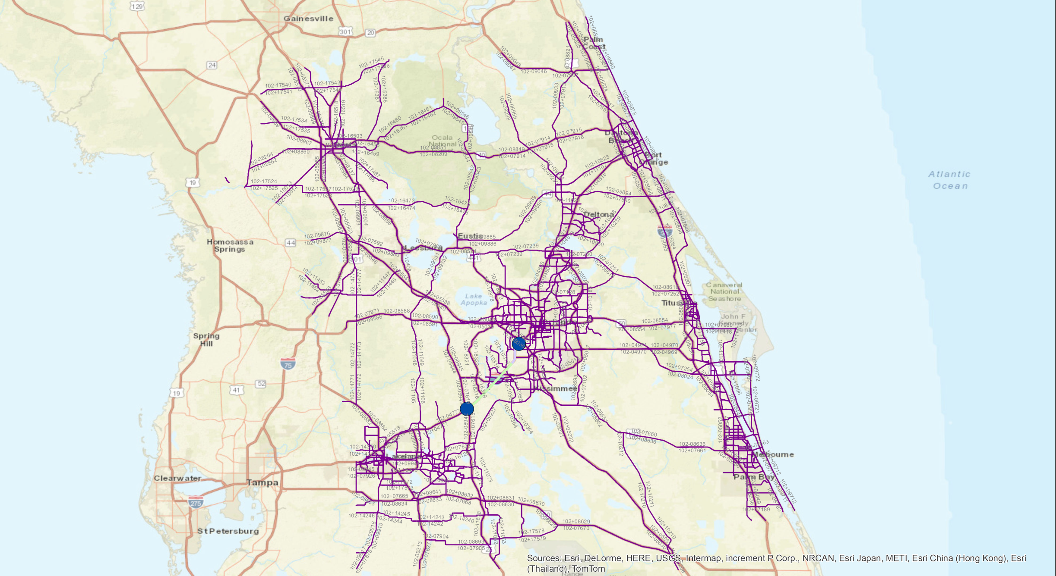

# Process and Analyze HERE Data

The travel time data obtained from HERE are in 5-minute increments and don’t include separate truck travel speeds. Traffic data are reported at the road link level on Traffic Message Channel (TMC) segments. The length of these TMC segments varies significantly – their starting and ending points are located at physical or logical geometric changes (e.g. interchanges). Each TMC has a unique TMC ID.

A TMC shape file was developed to show the locations and codes of available HERE TMCs in FDOT District 5 and Polk County. Exact locations of the TMCs are displayed in Figure 2. For most of the fifty TMCs in the I-4 study corridor, there is 5 minute HERE speed data for each day in 2014. Three of the fifty TMCs only have 5-min level speed data from January, 2014 to May, 2014. Ten TMCs didn’t have any speed data since these are interchange ramps and HERE didn’t collect data on ramps. Table 1 displays the date range of available HERE speeds by TMC ID.

Table : Here Speed Data Time Period

|  |  |
| --- | --- |
| TMCID | 5-Min Speed Data |
| 102+04779 | January, 2014 - May, 2014 |
| 102+04780 | January, 2014 - December, 2014 |
| 102+04781 | January, 2014 - December, 2014 |
| 102+04782 | January, 2014 - December, 2014 |
| 102+04783 | January, 2014 - December, 2014 |
| 102+04784 | January, 2014 - December, 2014 |
| 102+04785 | January, 2014 - December, 2014 |
| 102+04786 | January, 2014 - December, 2014 |
| 102+04787 | January, 2014 - December, 2014 |
| 102+04788 | January, 2014 - December, 2014 |
| 102+11563 | January, 2014 - December, 2014 |
| 102+18341 | January, 2014 - December, 2014 |
| 102-04778 | January, 2014 - December, 2014 |
| 102-04779 | January, 2014 - December, 2014 |
| 102-04780 | January, 2014 - December, 2014 |
| 102-04781 | January, 2014 - December, 2014 |
| 102-04782 | January, 2014 - December, 2014 |
| 102-04783 | January, 2014 - December, 2014 |
| 102-04784 | January, 2014 - December, 2014 |
| 102-04785 | January, 2014 - December, 2014 |
| 102-04786 | January, 2014 - December, 2014 |
| 102-04787 | January, 2014 - December, 2014 |
| 102-11563 | January, 2014 - December, 2014 |
| 102-18341 | January, 2014 - December, 2014 |
| 102N04779 | January, 2014 - December, 2014 |
| 102N04780 | January, 2014 - December, 2014 |
| 102N04781 | January, 2014 - December, 2014 |
| 102N04782 | January, 2014 - December, 2014 |
| 102N04783 | January, 2014 - December, 2014 |
| 102N04784 | January, 2014 - December, 2014 |
| 102N04785 | January, 2014 - December, 2014 |
| 102N04786 | January, 2014 - December, 2014 |
| 102N04787 | January, 2014 - December, 2014 |
| 102N04788 | January, 2014 - December, 2014 |
| 102N11563 | January, 2014 - December, 2014 |
| 102N18341 | January, 2014 - December, 2014 |
| 102P04778 | January, 2014 - May, 2014 |
| 102P04779 | January, 2014 - May, 2014 |
| 102P04780 | January, 2014 - December, 2014 |
| 102P04781 | January, 2014 - December, 2015 |
| 102P04782 | January, 2014 - December, 2016 |
| 102P04783 | January, 2014 - December, 2017 |
| 102P04784 | January, 2014 - December, 2018 |
| 102P04785 | January, 2014 - December, 2019 |
| 102P04786 | January, 2014 - December, 2020 |
| 102P04787 | January, 2014 - December, 2021 |
| 102P04788 | January, 2014 - December, 2022 |
| 102P11563 | January, 2014 - December, 2023 |
| 102P18054 | January, 2014 - December, 2024 |
| 102P18341 | January, 2014 - December, 2025 |
| 102P18965 | No Data Are Available |
| 102P18969 | No Data Are Available |
| 102P18971 | No Data Are Available |
| 102P18973 | No Data Are Available |
| 102P18975 | No Data Are Available |
| 102P18985 | No Data Are Available |
| 102P18987 | No Data Are Available |
| 102P18989 | No Data Are Available |
| 102P18991 | No Data Are Available |
| 102P18993 | No Data Are Available |

Figure : HERE TMC Locations

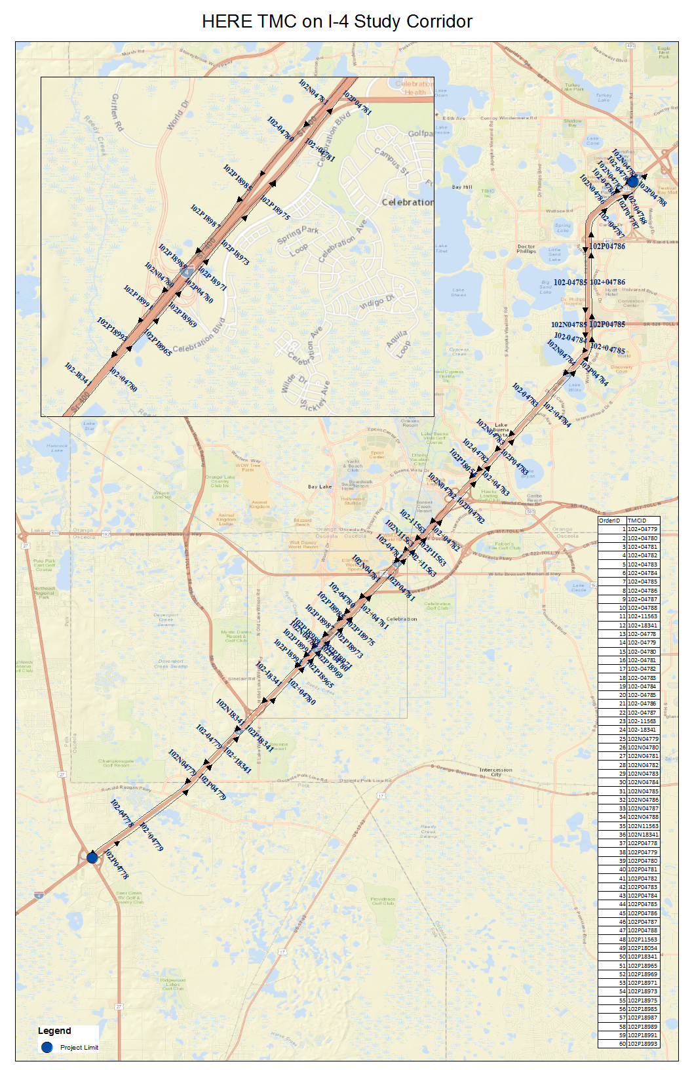

Table 2 and Table 3 give peak and off-peak months for each of 50 TMCs. The peak month for weekdays and the peak month for weekends are different when using average speeds and median speeds. Table 4 provides details on the differences between the average and the median speeds for the month of May.

Table : Peak and Off-peak Months Using Average Speeds



Table : Peak and Off-peak Months Using Median Speeds



Table : Average and Median Speeds Difference in May and July



Table 5, Table 6, and Table 7 give highest and lowest hourly speeds for peak and off-peak month weekdays, weekends, and holidays for each of 50 TMCs. The cells highlighted in pink color indicate that the differences of speeds are more than 30 mph between highest hourly speeds and lowest hourly speeds. The cells highlighted in green color indicate the most frequent hours with highest speeds or lowest speeds.

Table : Highest and Lowest Hourly Speed in Pk Month Weekday and Off-Pk Month Weekday



Table : Highest and Lowest Hourly Speed in Pk Month Weekend and Off-Pk Month Weekend



Table : Highest and Lowest Hourly Speed in Pk Month Holiday and Off-Pk Month Holiday



### Speed Data Check at TMCs close to Tukey Lake Road and Vineland Rd

Based on the data provided, we didn’t believe the travel speeds from either Vineland Road or Turkey Lake Road were mistakenly associated with I-4.

The lowest peak speeds on I-4 in the area of Vineland Road range between 49 and 50 mph. When we compared the lowest peak speeds on Vineland Road, a signalized arterial, they are much lower than 49 mph. The Vineland Avenue, that runs parallel to I-4 towards the southern end of the study area that seems more likely to have speeds that can be associated to I-4. Vineland Avenue is only 75 feet from I-4, this short distance may cause the speeds to be read incorrectly.

The portion of I-4 running parallel to Turkey Lake Road has speeds with greater variation - ranging from 46 to 32.5 mph. The highest speeds reported on Turkey Lake Rd in the peak are 30 mph from Florida Turnpike Enterprise’s Traffic and Revenue (T&R) Study. If the lowest speeds from Turkey Lake Road were incorrectly associated with I-4 they would likely be far less than 32.5 mph. So we believe the speeds on I-4 parallel to Turkey Lake are likely representative of traffic on I-4.

### Review HERE data from the Florida Turnpike Enterprise’s Traffic and Revenue (T&R) Study South Section BtU Traffic and Revenue (T&R) Study[1]

##### Floating Car Runs

In the T& R study, speed data collection was performed on I-4 using the floating car method for two midweek days in August 2015, which aims to place the speed of the data collection vehicle at the 50th percentile by aiming to pass a number of vehicles equal to the number of vehicles which pass the data collection vehicle. Table 8 below shows the results for I-4.

Table : I-4 – Field Collected Average Speeds



The floating car method has limited sample size, so it may not be comparable to the HERE data used in this study.

##### HERE Data

FDOT staff provided aggregated Nokia HERE speed data for the last two weeks of July 2014. The HERE speed data were available only for Apopka-Vineland Road and partial segments on Turkey Lake Road. The data were not available for International Drive. HERE data for I-4 were not requested or used in the T&R analysis, as other sources (i.e., floating car and SunGuide) were available. Table 9 and Table 10 below present the HERE speeds on Apopka-Vineland Road and Turkey Lake Road, respectively.

Table : Apopka/Kissimmee Vineland Road – Nokia HERE Speeds



Table : Turkey Lake Road – Nokia HERE Speeds





As shown in Table 9, Apopka-Vineland Road travelers experience speeds below 21 MPH from I-4 to Winter Garden Vineland Road/Palm Parkway. The average speed for this segment is approximately 18 MPH. Along Turkey Lake Road, speeds stay relatively constant between 22 and 31 MPH in both the AM and PM peak periods, as well in the northbound and southbound directions across all segments of this corridor.

1. Monthly Weekday, Weekend and Holiday Box Plots
2. Hours of Peak Month and Off-peak Month Weekday, Weekend and Holiday Box Plots
3. Average and Median Speeds of Peak Month and Off-peak Month Weekday, Weekend and Holiday

1. *I-4 Beyond the Ultimate: Kirkman Rd./SR 435 to US 27 Planning Level Traffic and Revenue Study*

   Technical Memorandum 2.1: Balanced Traffic/Operations Profile (November 2015)